Setup a Cinder Application

In this assignment, you will create a new Application using the libcinder framework. This assignment will guide you through the basic steps of creating a new windows console application, configuring include and library directories as well as library dependencies that are necessary for cinder.

# Create a new Console Application

First, open Visual Studio 2013 and create a new ‘C++ Commandline Application’ in a new solution. In the screenshots below, the Solution will be created in the folder p:\trainings\designpatterns\Sample\. The location will differ four your example.

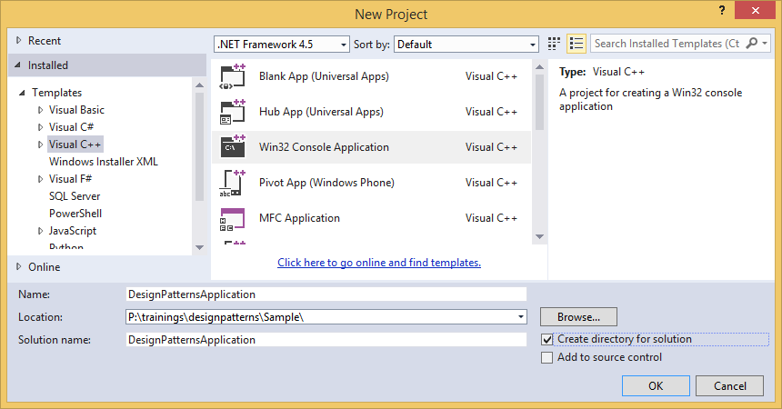

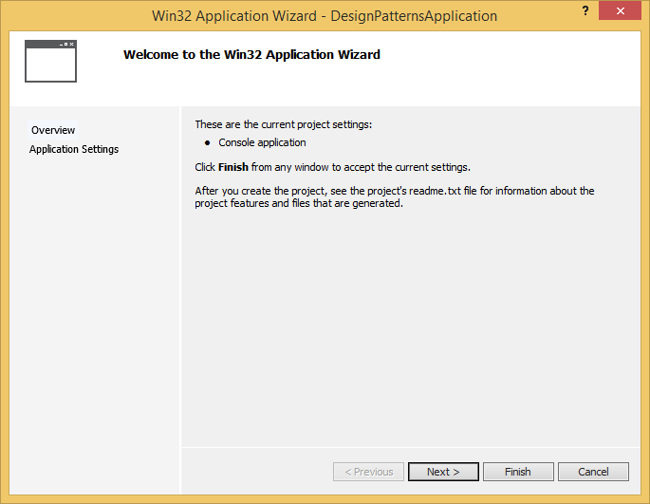

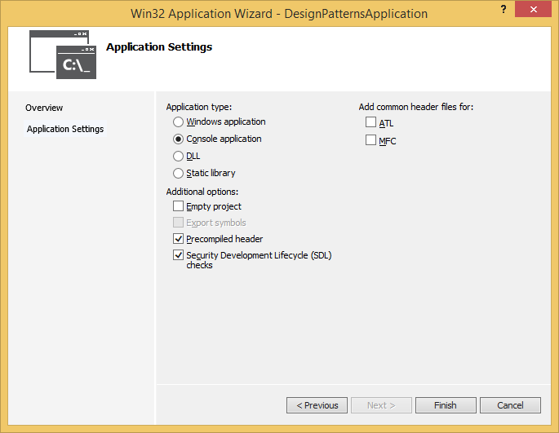

A new solution with a single Application called DesignPatternsApplication should be created for you:

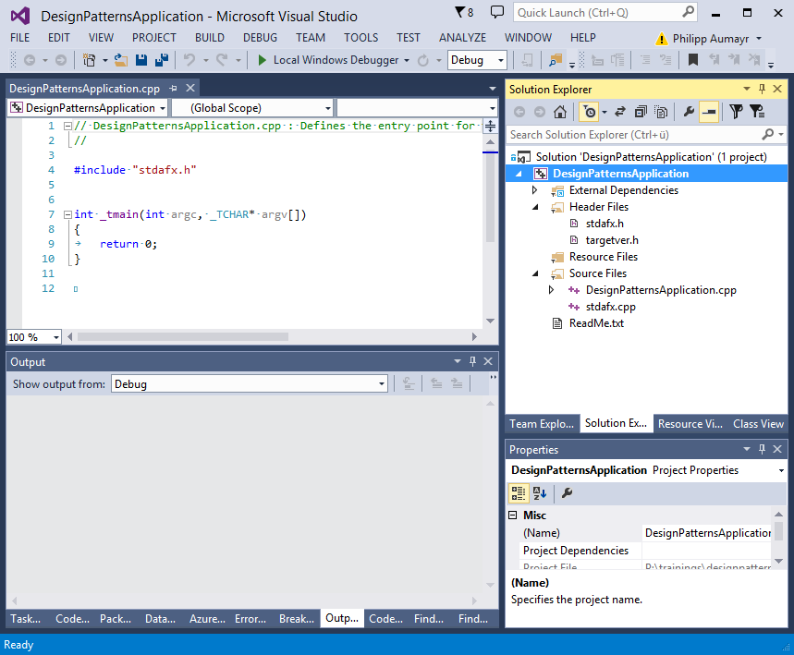

Next, we will add a reference to cinder. Open the Properties (context Menu of Project, or Alt + Enter) of the Project and open the “VC++ Directories” page: 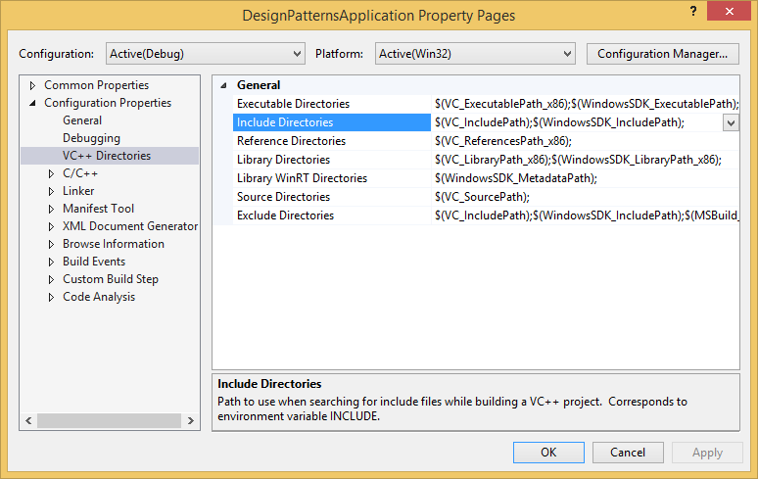

We will add a directory to the include folder of your local cinder installation. Here, cinder is installed at P:\software\cinder\cinder_0.9.0_vc2013. The required include directory therefore has to be set to P:\software\cinder\cinder_0.9.0_vc2013\include. We will add a Library directory (the linker searches this directory for libraries) pointing to the folder P:\software\cinder\cinder_0.9.0_vc2013\lib\msw\x86\.

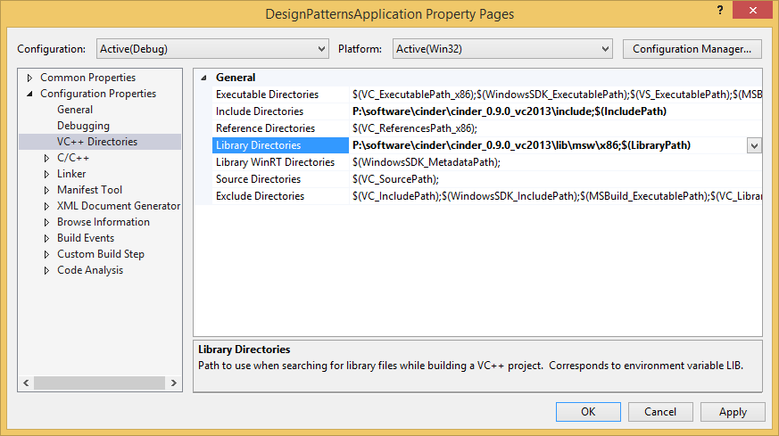

Next, we will add a reference to the cinder library by adding it as a linker dependency. Open Linker -> Input pane and add an entry for cinder-$(PlatformToolset)_d.lib .

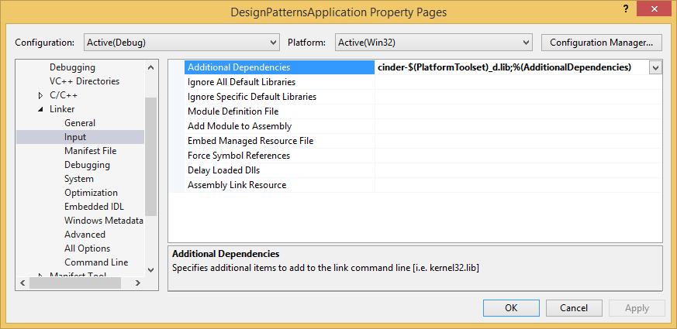

As the libraries used by cinder conflict with the default LIBCMT library, we will exclude that specific default library setting the ‘Ignore Specific Default Library’ setting to LIBCMT:

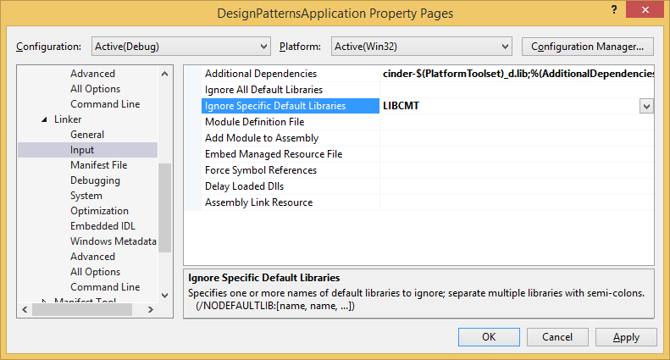

The last setting we have to change for cinder is the ‘Runtime Library’ setting. It can be found in the ‘Code Generation’ tab. By default, ‘Multi-threaded Debug DLL’ is used and we have to change it to ‘Multi-threaded Debug’ (note the missing DLL suffix) to align it with what the pre-compiled cinder binaries use:

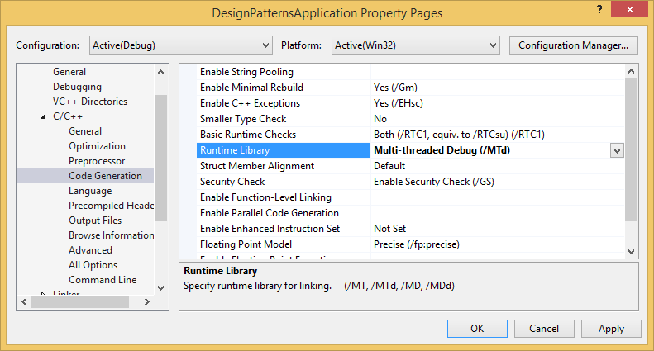

Close the ‘Property Pages’ by clicking ‘OK’ and recompile the application. It should compile without any linker errors.

Next, we will add a basic Cinder application by changing the code in “DesignPatternsApplication.cpp” to contain the following code:

